**How to Set up Your Test Automation Environment (Web)**

This document provides a brief guide on setting up your Windows system to create and run automation test scripts using a node.js automation test framework.

# **Step-by-step guide**

In order to set up your system to run automated tests with Selenium Web driver using Mocha, you need to follow these five simple steps:

* Download and install node.js
* Create batch file for Selenium Hub
* Download chrome driver and place in your system path
* Install mocha and xunit-file globally
* Start server and run tests

Now let’s get started:

## **Download and install node.js**

Before installing node.js, you need a java development kit (jdk) on your machine. You can download it from <http://www.oracle.com/technetwork/java/javase/downloads/jdk8-downloads-2133151.html>

Navigate to <https://nodejs.org/en/download/current/> where you can download the latest node.js pre-built installer for your platform.

Run the installer package and follow the instructions. Node.js comes with the node package manager (npm). You now have npm and node.js installed.

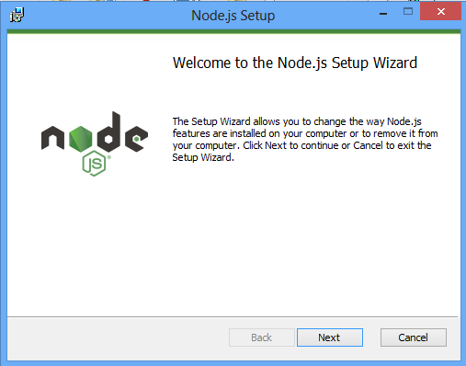

Restart your computer to update system changes and to get everything working fine in the Command Line Interface (CLI). Confirm that you have node.js installed on your system by typing “node –v” in command prompt.

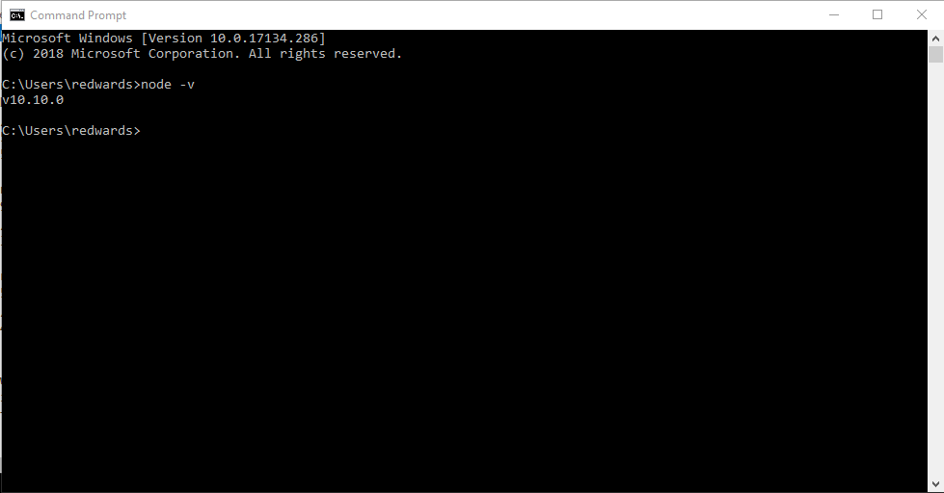

**\*\*NOTE:** It is always advisable to create a folder in your drive to store all drivers and test scripts as this provides a neat and easy way to manage files related to your selenium projects.

## **Edit batch file for Selenium Hub**

You need to edit two .bat files to point to your file path that comprises the Selenium Hub in the “server-hub” folder.

* **Grid Server:** Open your text editor and edit the following text: “Java –jar C:\Users\redwards\Documents\Rafa\softalliancetest\server-hub\selenium-server-standalone-3.0.1.jar -role hub -browserTimeout 240”

Change the path to match the folder Selenium Standalone Server is located. Save file name as “Grid Server.bat” in the same location as Selenium Standalone Server.

* **Grid Nodes**: Open your text editor and edit the following text: “Java -jar C:\Users\redwards\Documents\Rafa\softalliancetest\server-hub\selenium-server-standalone-3.0.1.jar -role node -browser browserName=firefox,maxInstances=40 -browser browserName=chrome,maxInstances=40 -browser browserName=iexplore,maxInstances=5 -hub http://localhost:4444/grid/register”

Change the path to match the folder Selenium Standalone Server is located. Save file name as “Grid Nodes.bat” in the same location as Selenium Standalone Server.

## **Place chrome driver in path**

Go to “driver” folder.

Place the chrome driver in your system path by editing the system variable.

* Right click on the “chromedriver.exe” file, click on “Properties” then copy “Location”.

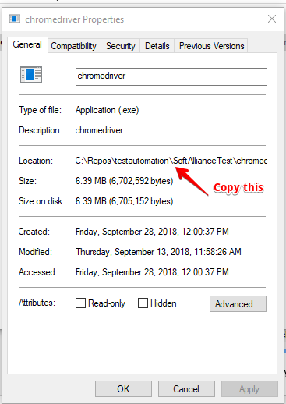

* Click on Control Panel >> System and Security >> System >> Advanced System Settings >> Environment Variables
* Under “User variables”, scroll down and double-click on “Path”
* Add a semi-colon and paste the Location you copied earlier then click “OK” (Win 7 & 8)
* Paste the Location you copied earlier on an empty row then click “OK” (Win 10)

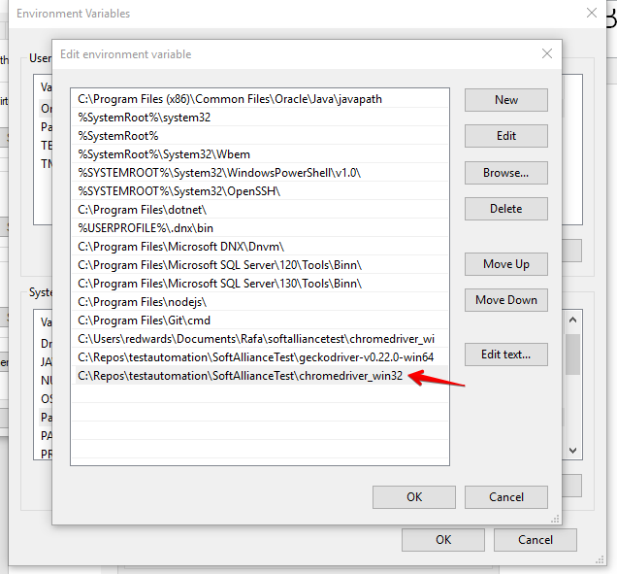

* Finally confirm the path has been added by typing “path” in the command prompt.

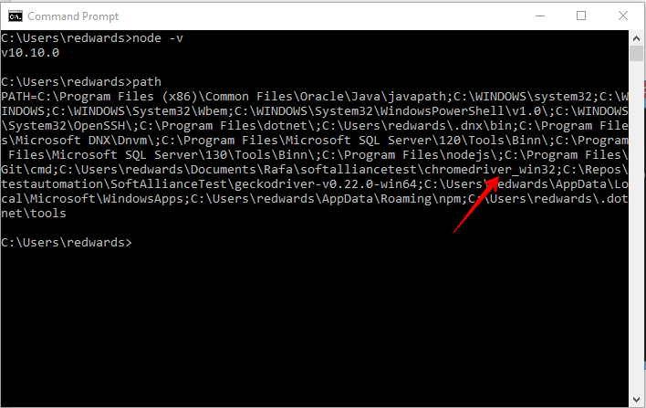

## **Install mochawesome, mocha and xunit-file globally**

Install mocha globally by typing “npm install –g mocha” in command prompt.

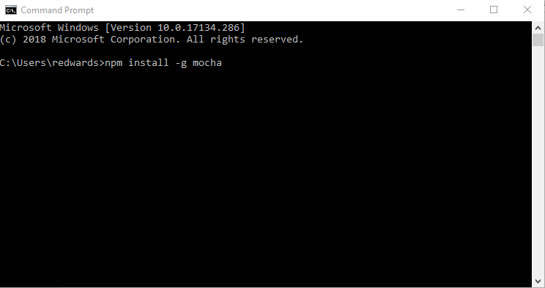

Install xunit-file globally by typing “npm install –g xunit-file” in command prompt.

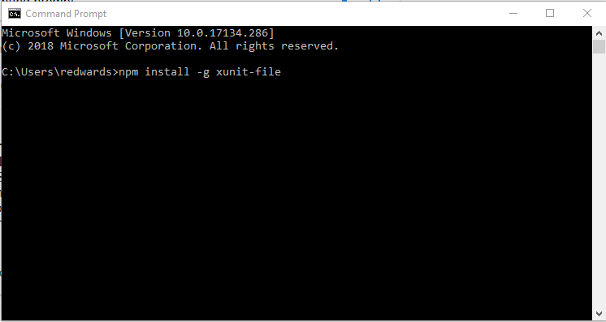

## **Start server and run tests**

You can start the Selenium Server Hub by navigating to the “server-hub” folder and first clicking on “Grid Server” and then on “Grid Node”

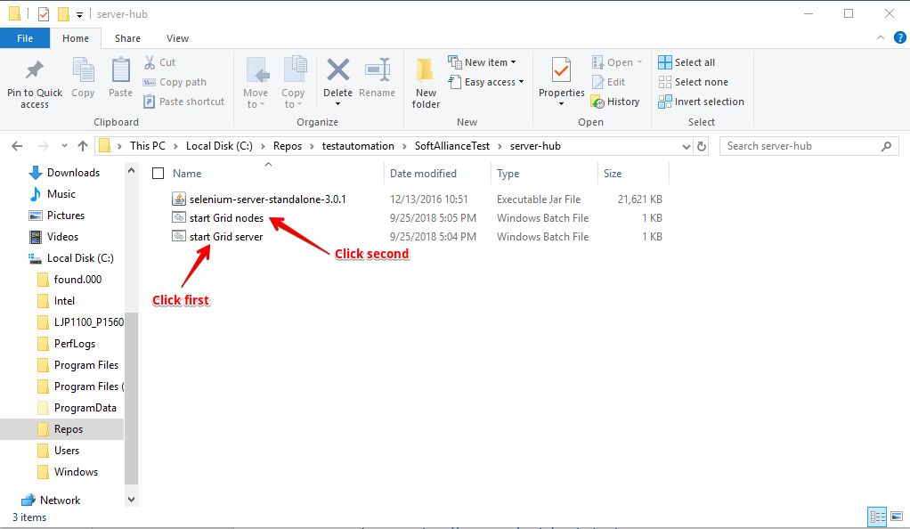

To run a test script from command prompt, simply change directory to the “softalliance” then type: “npm test”

**\*\*NOTE:** You can find a full list of commands’ help by typing “mocha -h” in cmd or directing your browser to <http://unitjs.com/guide/mocha.html>